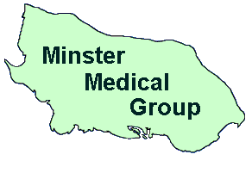
Welcome to Sheppey Healthy Living Centre/ Branch Surgery: Minster Medical Centre
Minster Medical Centre
Minster on Sea
Sheerness
Kent
ME12 3LT
Tel: 01795 877714
Surgery website: www.sheppeyhealthylivingcentre.co.uk
Patient email: kmicb.minstermedical@nhs.net
Patient Newsletter – 2025/2026
Update on the Sheppey Healthy Living Centre located in Sheerness:
We understand that many patients have strong feelings about our proposal to permanently close the Sheppey Healthy Living Centre (SHLC) site and continue providing services from Minster Medical Centre. We would like to reassure patients that no decisions have yet been made. The consultation remains ongoing, and we are carefully considering all feedback received from patients, stakeholders and community organisations before reaching any final decision.

Importantly, this proposal does not involve a reduction in GP services, doctors, nurses or clinical staff. Patients will continue to receive care from the same healthcare professionals, and our commitment to providing high-quality healthcare for all our patients remains unchanged. We appreciate the time many of you have taken to share your views and would like to thank everyone who has participated in the consultation process.

You can book face to face appointments with the GP, by calling on the day at 8am for same day appointments on 01795 877714. Please press option 3 for appointments from 8am. Please note: 10 minute GP appointment = 1 health issue, If you have more than 1 health issue, Please book a double appointment.

For test results (option 2) or general enquiries (option 4). Please call between the hours of 11am to 3pm.
You can also book GP appointments for the same day by booking via the GP app from 8am. Across the week, appointments are now available to pre-book via the app. Please visit our website for more information. You can also submit an eConsult on our website. Please see next page for more information.

Prescription Requests
Please request your medication 2 to 3 days before you are due to run out of your medication either in writing or by email. Please DO NOT call the surgery to request your medication. For prescription queries, please call between the hours of 11am to 3pm and select option 1.
To request your medication you can email the surgery on:
kmicb.minstermedical@nhs.net

Please allow 48 hours for your prescription to be ready. We are able to send prescriptions electronically to a local pharmacy of your choice. Please inform us which pharmacy you would like to use.

If you wish to have your blood test at Sheppey Community Hospital Phlebotomy Clinic. This is now a walk in service. This is open Monday to Friday 8am till 1:30pm. Please remember to take your blood test forms with you to the blood clinic.
Sheppey Community Hospital X-Ray

The x-ray department is open Monday to Friday 8am to 8pm (closed at 1pm to 1:30pm for lunch). Saturday and Sunday 9am to 6pm. The new telephone number for the X-ray department at Sheppey Community Hospital is 01634 825202. Please make sure you have your X-Ray form from the surgery and is signed by the GP. You no longer need an appointment.
If you require a CHAPERONE for your appointment. Please inform reception or the clinician.
Patient contact details
Please update your address and telephone numbers at reception, in writing or by email.

We do have a ZERO-TOLERANCE POLICY in place. Please DO NOT be rude to staff. We accommodate our patients in the best possible way, we are here to help you and your health needs.
HALF DAY CLOSURE
Tuesday 16th June 2026 – the surgery will be closed from 1pm for staff training. Please call 111 if you need medical assistance.
9
We now offer a service called eConsult. This allows you to complete an online self –referral form, which is reviewed by a clinician and is dealt with appropriately. Please follow the link on our website to complete the form.
www.sheppeyhealthylivingcentre.co.uk

Alternatively, we can refer you to the local pharmacy who can see patients for the following symptoms:
- Uncomplicated Urinary Tract Infection (women aged 16-64 years)
- Impetigo (adults and children aged 1 year and older)
- Infected Insect Bites (adults and children aged 1 year and older)
- Acute Sore Throat (adults and children aged 5 years and older)
- Acute Sinusitis (adults and children aged 12 years and older)
- Shingles (adults aged 18 years and older)
- Acute Otitis Media (children aged 1 to 17 years)

Please visit our website for more information: www.sheppeyhealthylivingcentre.co.uk
If you wish to be part of our patient engagement group. Please email swccg.yourvoice@nhs.net.
We would like to hear your views and ideas on how to improve our service. Please note: this email is NOT for clinical requests or personal issues.
Cancer Awareness Month
JUNE:
LGBTQ+ Pride
Men’s Health Week (8th to 14th June)
National Cancer Survivor’s Day (7th June)
Refugee Week (15th to 21st June)

For more information. Please visit www.macmillan.org.uk

Patient Online Access is available to download via your phone or home desktop. Please ask at reception for more information and to activate your account. We can print or email your account ID and Linkage Key. Please be aware when registering for this service you will need to enter: Sheppey Healthy Living Centre, Royal Road, Sheerness ME12 1HH as your registered GP surgery.

If you have just found out you are pregnant. You will need to visit www.medway.nhs.uk select OUR SERVICES, click on M for Maternity, click on Congratulations You’re having a baby, click on Complete the online referral form and complete the form and submit. Please contact the surgery for your NHS number if you do not know it.

The surgery is offering the RSV vaccine (respiratory syncytial virus). The vaccine helps to protect women during pregnancy (from 28 weeks onwards) and for adults aged 75 to 79. For more information, please visit the NHS website.
Stop Smoking
For help, advice and support. Please visit: www.kent.gov.uk/social-care-and-health/health/one-you-kent/quit-smoking
You can text QUIT to 60163, phone 0300 123 1220 or fill in their fast referral form for One You Kent

Out of Hours Services:
UTC (Urgent Treatment Centre) is located inside Minster Medical Centre - open every day, 8am to 8pm.

Minor Injury Unit is located inside Sheppey Community Hospital - open every day, 8am to 8pm.

If you need advice or treatment, you can also call 111.

DNA Appointments:

95 Patient’s DID NOT ATTEND their booked appointments during the month of May 2026.

Please can you contact the surgery ASAP if you are unable to keep your appointment, then it can be offered to another patient.

If you have a long term health condition, please call to book for an annual health check.

If you have a blood pressure machine at home, please take your readings for 4 to 7 days, morning and afternoon (if possible at the same time) and let us have the results.
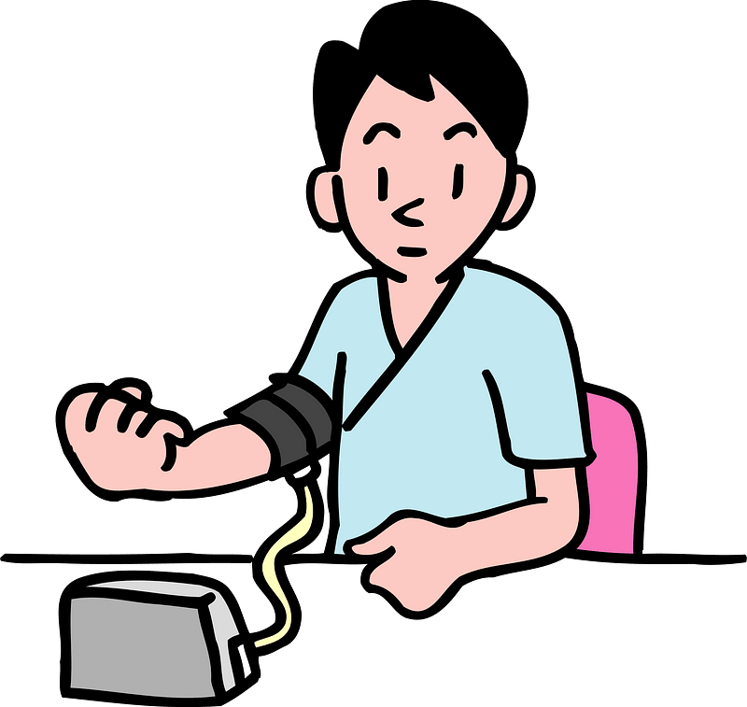
Please ask at reception for a blood pressure recording diary sheet to complete at home and return to the surgery for the GP to review your readings.

