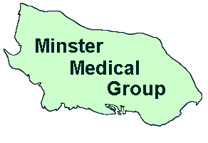
Minster Medical Group
Sheppey Community Hospital
Plover Road
Minster
Kent
ME12 3LT
01795 877714
Executive Manager: Helen Gaylor

Dear Patient

GP Earnings

Minster Medical Centre, Sheppey Healthy Living Centre and Long Catlis Road Surgery are all part of Minster Medical Group. We have two Swale practices and one Medway practice.

All GP Practices are required to declare the mean earnings (e.g. average pay) for GP’s working to deliver NHS services to patients at each practice.

NHS England requires that the net earnings of doctors engaged in the practice is published and the required disclosure is shown below. However, it should be noted that the prescribed method for calculating earnings is potentially misleading because it takes no account of how much time doctors spend working in the practice and should not be used for any judgement about GP earnings, nor to make any comparisons with other practices.

The average pay for GPs working in the Minster Medical Group in the last financial year was £48,748 before tax and national insurance. This is for 2 part time GPs and 7 locum GPs who worked in the practice for more than 6 months.

